- Write a DDL command to create STUDENTPROJECT table as shown in Appendix A

SQL statements:

- Modify STUDENT table to change the length of st_name column from 10 to 40.

SQL statements:

- Prepare only ONE (1) SQL statement that will update the values of ad_name in ADVISOR table to convert the first letter of each word to uppercase (e.g. title case). For example daud che ngah to be converted to Daud Che Ngah.

SQL statements:

- Give privilege to Salmi to select, insert, update and delete on ADVISOR table.

SQL statements:

With reference to the table that have been created as shown in Appendix A, write an appropriate SQL statement for the following questions.

- Display student no, student name and student date of birth for those students obtain cgpa above 3. Label the columns as StudentNo, Student Name, and DOB respectively. Order the query in ascending order by student name.
SQL statements:

- Analyze the following screenshot. Write a query that will produce output with the same format as the screenshot.

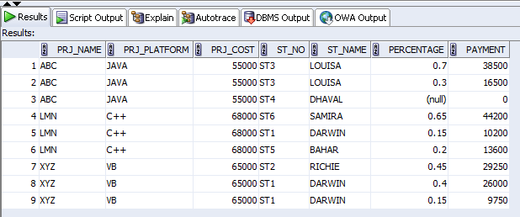

SQL statements:

- For each project, display project name, project platform, project cost and total number of student involved. Label the columns as ProjectName, ProjectPlatform, ProjectCost and TotalStudentInvolved respectively. Order the query in ascending order by ProjectName.
SQL statements:

- Prepare SQL statement to find more than ONE (1) students supervised by an advisor. Display advisor name and number of advisee. Label the columns as AdvisorName, and NumberOfSupervision respectively.
SQL statements:

- Display student no, student name and leader name for all students including those without leader id (i.e. null value). If exists null value, replace it with the value of ‘BigBoss’. Order the query in ascending order by the student id column. Give appropriate labels.
SQL statements:

- Display student no, CGPA and project type. Project type is based on the following condition :
st_cgpa < 2.0 Project type = ‘Please Consult Your Supervisor’.
st_cgpa >2.0 and <=2.5 Project type = ‘Type D’.
st_cgpa >2.5 and <=3.0 Project type = ‘Type C’.
st_cgpa >3.0 and <=3.5 Project type = ‘Type B’.
st_cgpa >3.5 Project type = ‘Type A’
.
Label the columns as StudentID, StudentCGPA and ProjectType respectively.
SQL statements:

- Display project no., project name, project duration, project platform and project cost for project below average of project cost. Give appropriate labels. You are required to use sub-query in answering this question.
SQL statements:

- Display number of students, number of advisor and total cost of all projects. Your output must be in the same format as shown in the following screenshot.

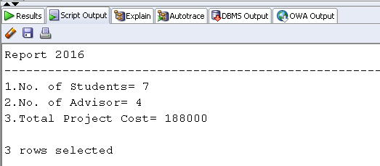

SQL statements:

